Angewandte Physik und Messtechnik, LRT 2
Prof. Dr. Günther Dollinger
02.12.2014

Master Thesis

Understanding the enhanced radio-biological effectiveness (RBE) of high energy heavy ions

High LET (linear energy transfer) radiation like heavy ions is well known to induce a higher relative biological effectiveness than low LET radiation. The dependence of RBE with LET is of special interest for heavy ion tumor therapy and for radiation safety issues.
We elucidate the different contributions to RBE-enhancement by using an ion microbeam approach. With the ion microbeam SNAKE at the Munich tandem accelerator, low LET 20 MeV protons (LET in water: 2.65 keV/µm) can be applied either in random distribution or in submicron beam spots (see fig.) . This allows modifying the DNA damage distribution from random up to highly concentrated damage distribution, which is typical for high LET ions but avoiding extreme dose peaks in the track center, which may change the number and complexity of DSB. We compare the RBE with respect to cell survival and other endpoints of both application forms to that of carbon ion irradiation.
20 MeV protons
5 × 5 µm² matrix
117 protons per spot
The work will concentrate on experimental work in systematically varying the beam diameter and the time structure in the proton irradiation experiments. In addition, further reduction of beam diameter and varying the time structure of the proton pulses will be tackled.

The work will give insight into radiation physics, ion beam optics, optical microscopy and biophysics.
Microscopic images of double strand break distributions in cell nuclei that were irradiated by carbon ions, randomly distributed protons or focused protons
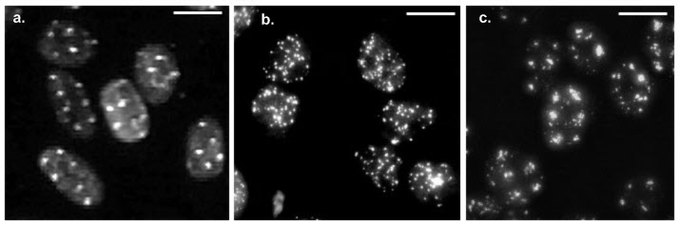
.
55 MeV carbon
5 × 5 µm² matrix
20 MeV protons
randomly distributed
20 MeV protons
5 × 5 µm² matrix
117 protons per spot

